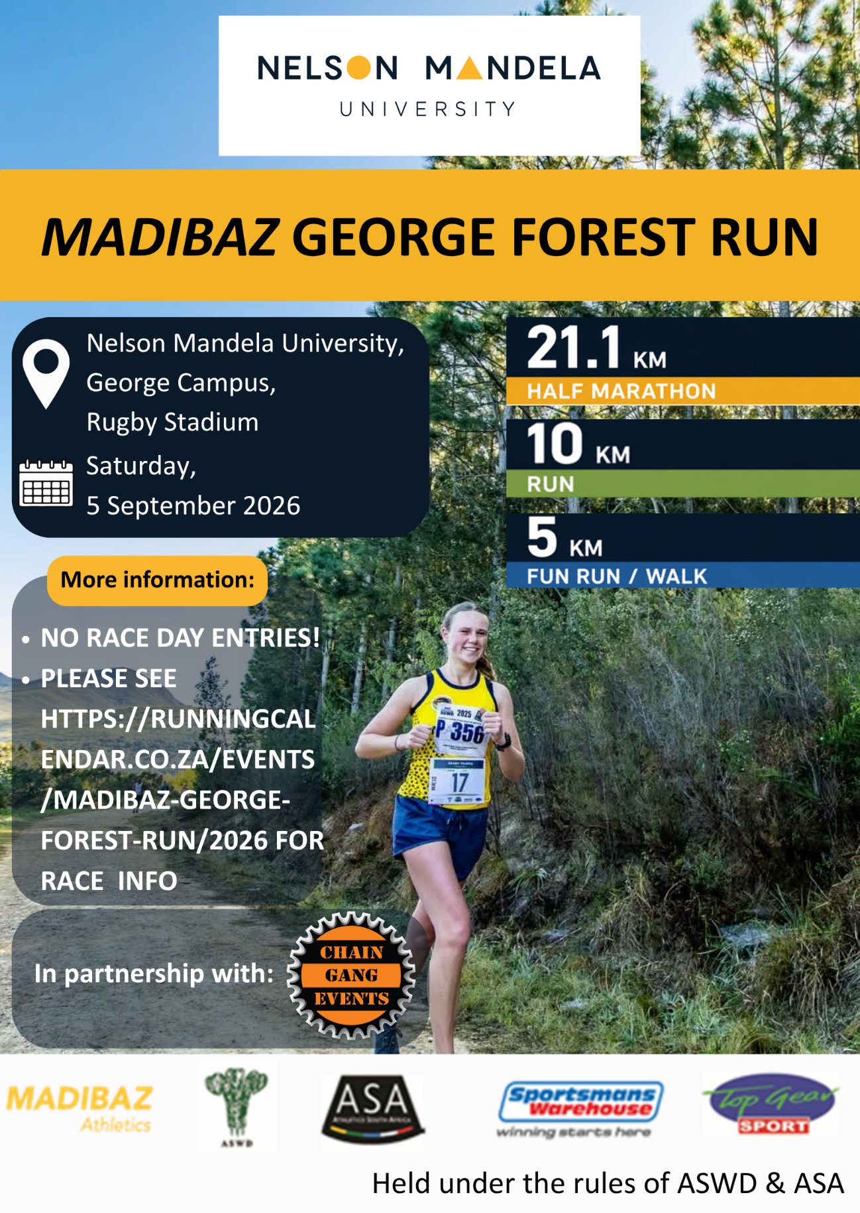

Rules and Regulations
Held under the rules of ASA and ASWD. All competitors must comply with the rules, regulations and instructions given by officials, marshals, and traffic officials. Non-compliance may lead to disqualification. The Race Referee’s decision is final. The Race Organiser reserves the right to accept/reject any entry received.
Club Colours: Affiliated club athletes must participate in official club colours and display their ASA 2026 license numbers on the front and back of the vest. All other runners must display temporary number on front of vest.
Pre-entries: Enter online at https://www.entryninja.com/events/83991-madibaz-george-forest-run-26 or Manually at Top Gear Sport / Sportman’s Warehouse. Closing date for pre-entries is, Wednesday, 2 September 2026 @ 17h00. Entry fees are non-refundable.
Late entries: On Friday (4 September) between 13h00 – 18h00 at Sportman’s Warehouse and Top Gear. No race day entries. (No Card Facilities, Cash Only). These entries will attract a R25 premium to the advertised rates.
Temporary License: Temporary Licensed athletes will not be covered by the ASA National Runner insurance.
Start & Finish: Race will start and finish at the Rugby Stadium.
21.1km @ 08H00. 10km @ 08H10. 5km Fun Walk / Run @ 08h20.
Race numbers: The race number must be placed over the permanent in a manner that the ASA License Sponsor and ASA Province / Year is visible above the race number. Athletes need to indicate whether they will collect their race numbers from Top Gear Sport (13h00 - 17h00), Sportman’s Warehouse (13h00 – 18h00) or at the venue on race day. Race numbers to be collected on Friday, 4 September 2026 at selected locations and at the venue on race day between 06h30 – 07h45.
Age Tags: Official ASWD age category tags must be displayed on the front and back of your vest to qualify for age category prizes. Athletes using a temporary license number will be required to produce their proof of age on race day to qualify for prizes.
Seconding: No personal seconding is allowed due to access restrictions.
Safety Rule: Wearing of earphones or headsets and animals is not permitted and will lead to disqualifications.
Refreshment Tables: Water stations shall be provided at 3km intervals or more frequently if weather conditions warrant such provision. Water and other suitable refreshments shall be available at the start and finish.
Cut-off times: 21.1 km @ 11h30, 10km @ 10h30 and the 5km Fun Run @ 09h55.
Ablution: Toilets will be available at the start & finish area, but no shower facilities.
Distance markers: Will be placed at every kilometre for the 10km and 21.1km.
Route: Paved Road and undulating gravel through the forest.
Anti-littering rules apply: Refuse bins will be provided along the route. Please discard your cups into or near to these bins.
Photos: Will be uploaded on this Facebook page: Gerber Sport Photography
Enquiries: Route ->Mr Hugo Loubser – 082 575 1826 / Hugo.Loubser@mandela.ac.za
Race administration -> Mr Juan Botes – 071 678 7174 / juan@chaingangevents.co.za
For more information visit https://runningcalendar.co.za/
RACE ENVELOPE: Your Race Envelope will contain 1 race number and safety pins. Your timing chip is attached to your race number and needs to be attached to the front of your running vest / t-shirt. Please do not bend or tamper with the chip in any way. NO CHIP NO TIME.

Entry Form
ADMIN USE ONLY
Chip Number |  | Temp. Number
DISTANCE – Tick appropriate box & collection point
21.1km |  | 10km |  |  |  |  |  |  | 5 km Fun Run |  |  |  |  | Top Gear |  |  |  | Race  venue |  | Sportman’s  Warehouse
First Name
Surname
Contact Number |  |  |  |  |  |  |  |  |  |  | ID Number
Club Name
2026 Licence Number
Date of Birth |  |  | d | d | m |  | m |  |  | yyyy |  | Age
Gender
Emergency Contact |  |  | Name: |  |  |  |  |  |  |  |  | Contact Number:
AGE CATEGORIES: JUNIOR / OPEN / 40–49 / 50–59 / 60–69 / 70–79 / 80 +
Race |  | Entry Fee |  |  |  |  |  | Temp License Fee |  |  |  |  | Minimum Age
5 km |  | R 45.00 |  |  |  |  |  | None |  |  |  |  | 5 years or older
10 km |  | R 95.00 |  |  |  |  |  | R 50.00 |  |  |  |  | 14 years or older
21.1km |  | R 125.00 |  |  |  |  |  | R 50.00 |  |  |  |  | 16 years or older
R10 added to your online fees.
INDEMNITY / DISCLAIMER By entering this event I undertake to be bound by the rules and regulations of the event including those of WA and ASA. I warrant that I am in good health and aware of the risks and dangers of physical nature of this sporting event, and do not claim ignorance of these risks and dangers. I hereby accept that I participate in the event entirely at my own risk and I release and discharge, to the fullest extent allowed in law, the organizers of the event, all sponsors, persons and organizations assisting in the staging of the event, provincial and national athletics bodies and all local authorities from any responsibility, liability or costs relating to any injury, loss or damage of whatever nature, however caused, arising directly or indirectly from my participation in the event including pre- and post-race activities. I further agree and warrant that if at any time I believe conditions to be unsafe, I will immediately discontinue further participation in the activity.
MINOR RELEASE: I the minor’s parent and/or legal guardian, understand the nature of athletic activities and the minor’s experience and capabilities and believe the minor to be qualified, in good health, and in proper physical condition to participate in such activity and I enter this Indemnity/waiver on behalf of the minor.
Printed name of participant (parent/guardian in the case of a minor) ……………………………………..................................................................................
Phone………………………...........…. Signature……………....…............………..… Date………....……………

Prize Money
21.1 km Race – Men & Women
Category | 1st | 2nd | 3rd
Open | R1 500 | R1 000 | R750
Junior | R350 | R250 | R100
35 – 39 | R350
40 – 49 | R350
50 – 59 | R350
60 – 69 | R350
70 - 79 | R350
80+ | R350
10 km Race – Men & Women
Category | 1st | 2nd | 3rd
Open | R700 | R400 | R250
Junior | R300 | R200 | R100
35 – 39 | R300
40 – 49 | R300
50 – 59 | R300
60 – 69 | R300
70 – 79 | R300
80+ | R300
- Prize giving will commence at the finish area at 11h45.
- You must be present to be eligible for the lucky draw prizes. All entrants are eligible for lucky draw prizes.
- Athletes using a temporary license number will be required to produce proof of age and display category tags on race day to qualify for prizes.
- All Prize winners must be in their club colours when collecting their prize. Winners must be present at prize giving otherwise the prize will be forfeited. No Exceptions!
- Equal prize money for both men and women.
- Medals: To all finishers who complete the race within the cut-off time.

